U23IT484 – Cloud Computing Technologies
Skill Assessment Test – 2
Name : Yogita R
Reg. No. : 722824148124
ROUND 2(I) – IMPLEMENT AWS STORAGE
STEPS:
1. Create S3 Bucket
Created an S3 bucket in the AWS Management Console for storing application data.
2. Configure Bucket
Enabled bucket versioning and server-side encryption.
3. Create Folders
Created three folders:
- application
- backup
- logs
4. Upload Files
Uploaded the required files into the respective S3 folders.
5. Verify Storage
Verified that the uploaded files were successfully stored in the S3 bucket.
Creation of S3 bucket for cloud storage
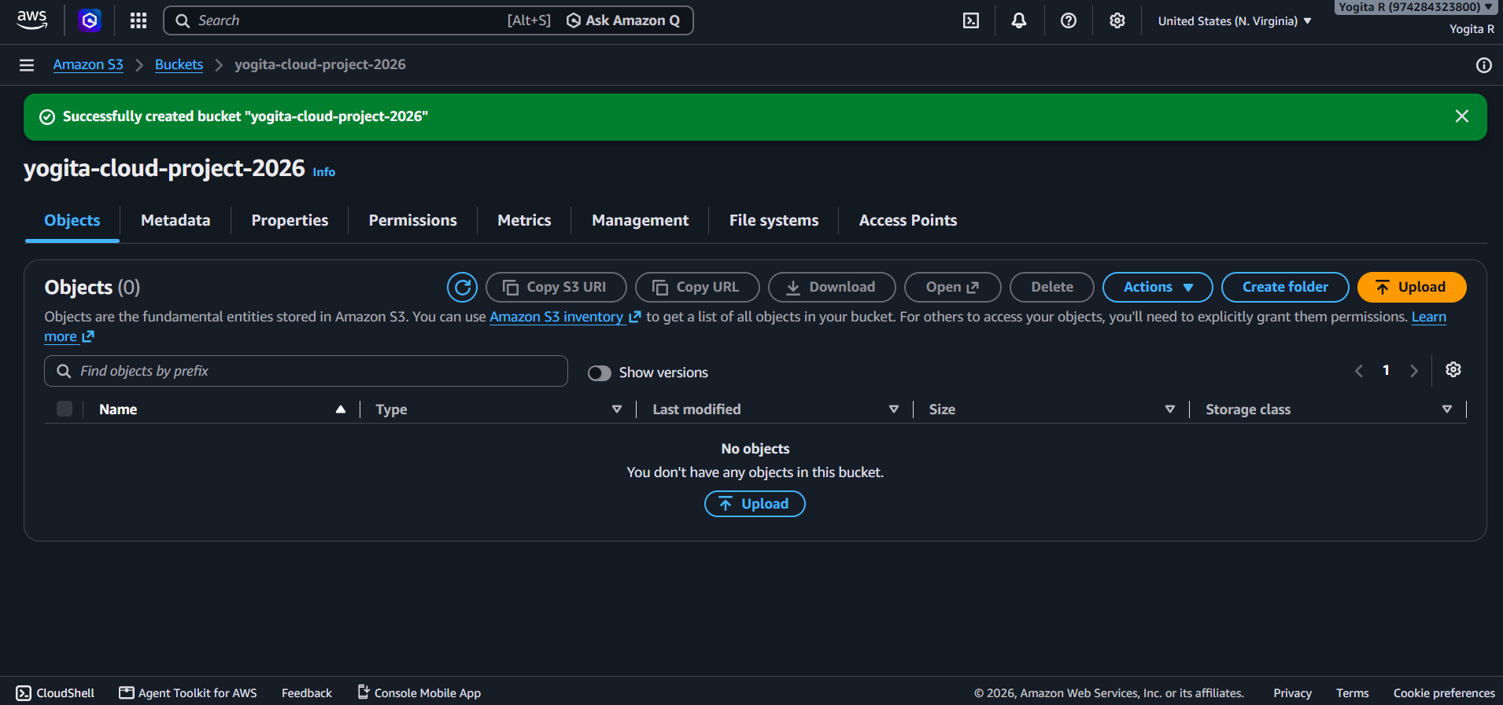

S3 bucket versioning and server-side encryption configuration
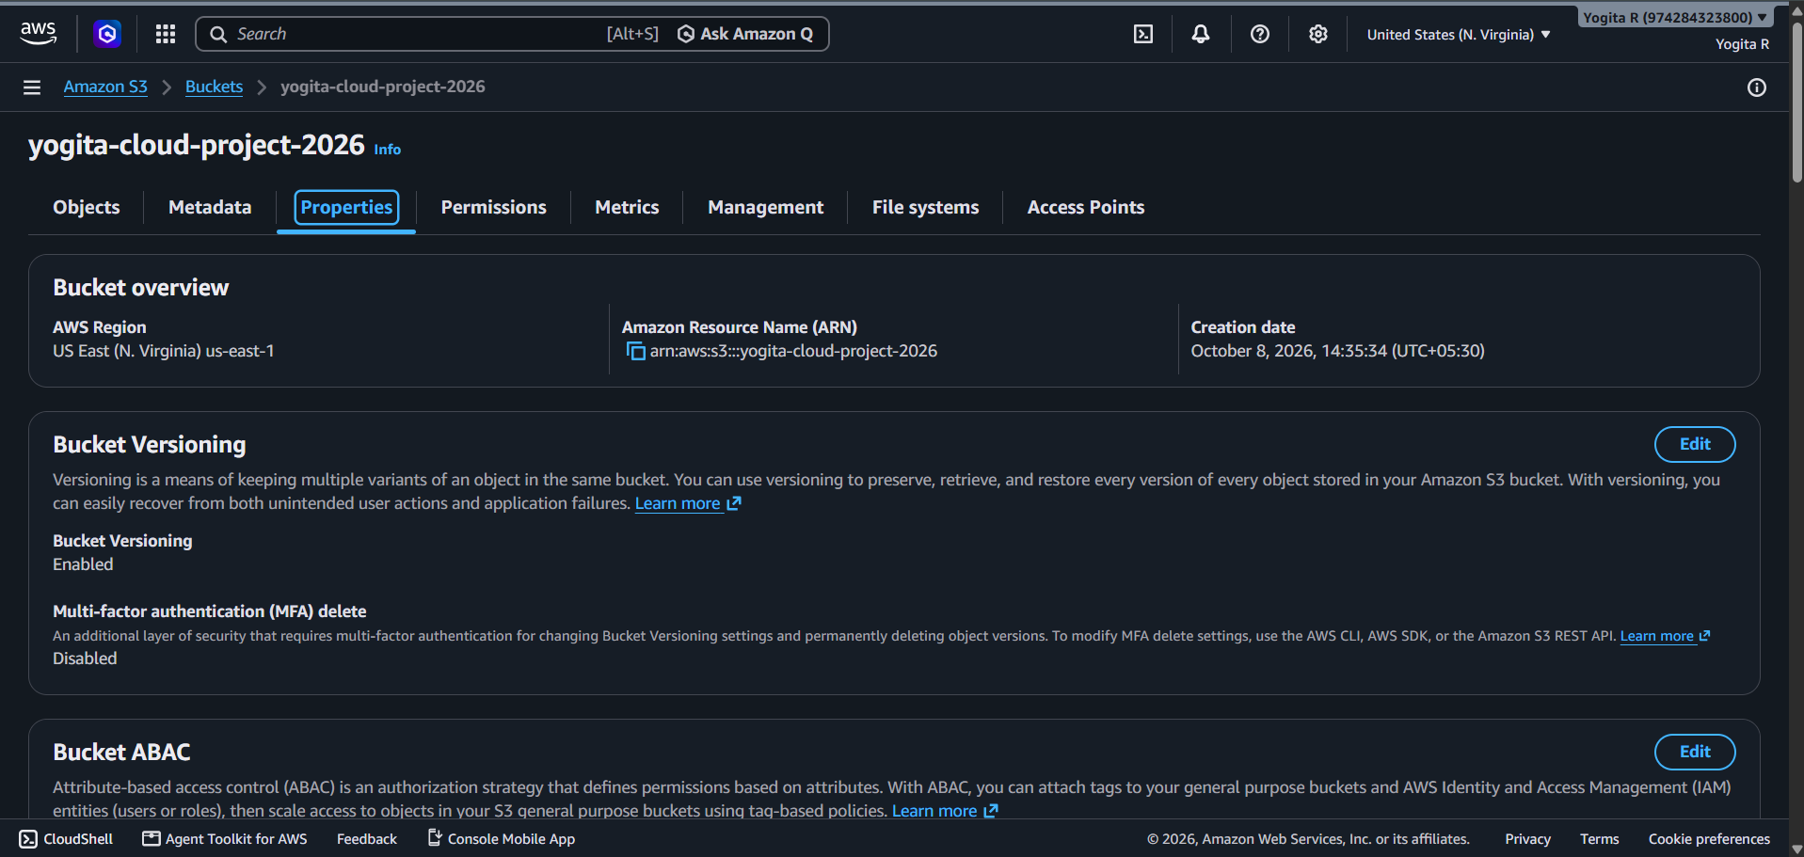
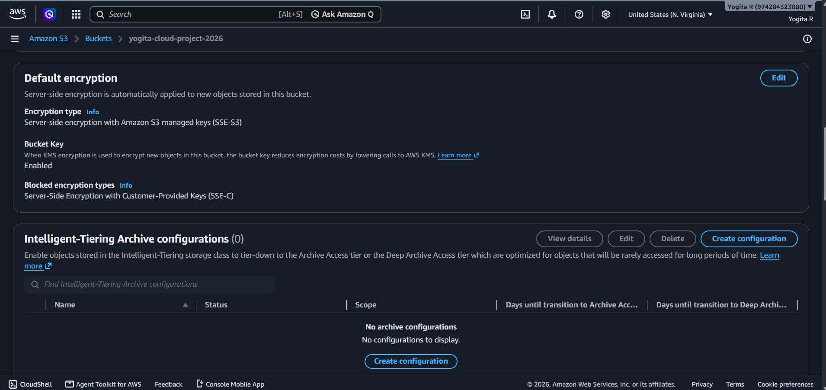
Files and folders uploaded to Amazon S3 bucket
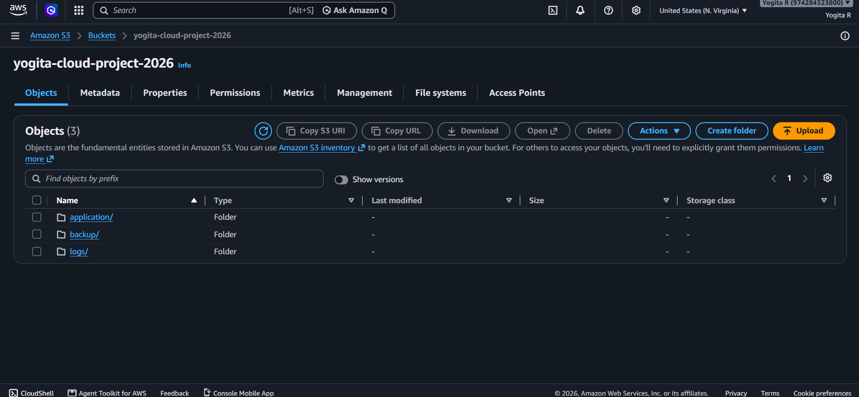

ROUND 2(II) - BUILD END-TO-END AWS SOLUTION
STEPS :
1. Create VPC
Created a VPC with the required IP address range.
2. Create Subnet
Created a public subnet inside the VPC.
3. Create Internet Gateway
Created an Internet Gateway and attached it to the VPC.
4. Configure Route Table
Created a route table and added a route to the Internet Gateway.
5. Associate Subnet
Associated the public subnet with the configured route table.
6. Create Security Group
Created a Security Group and configured the required inbound rules.
7. Launch EC2 Instance
Launched an EC2 instance inside the public subnet.
8. Verify EC2
Checked that the EC2 instance was running and that the status checks were successful.

AWS VPC configured for application hosting
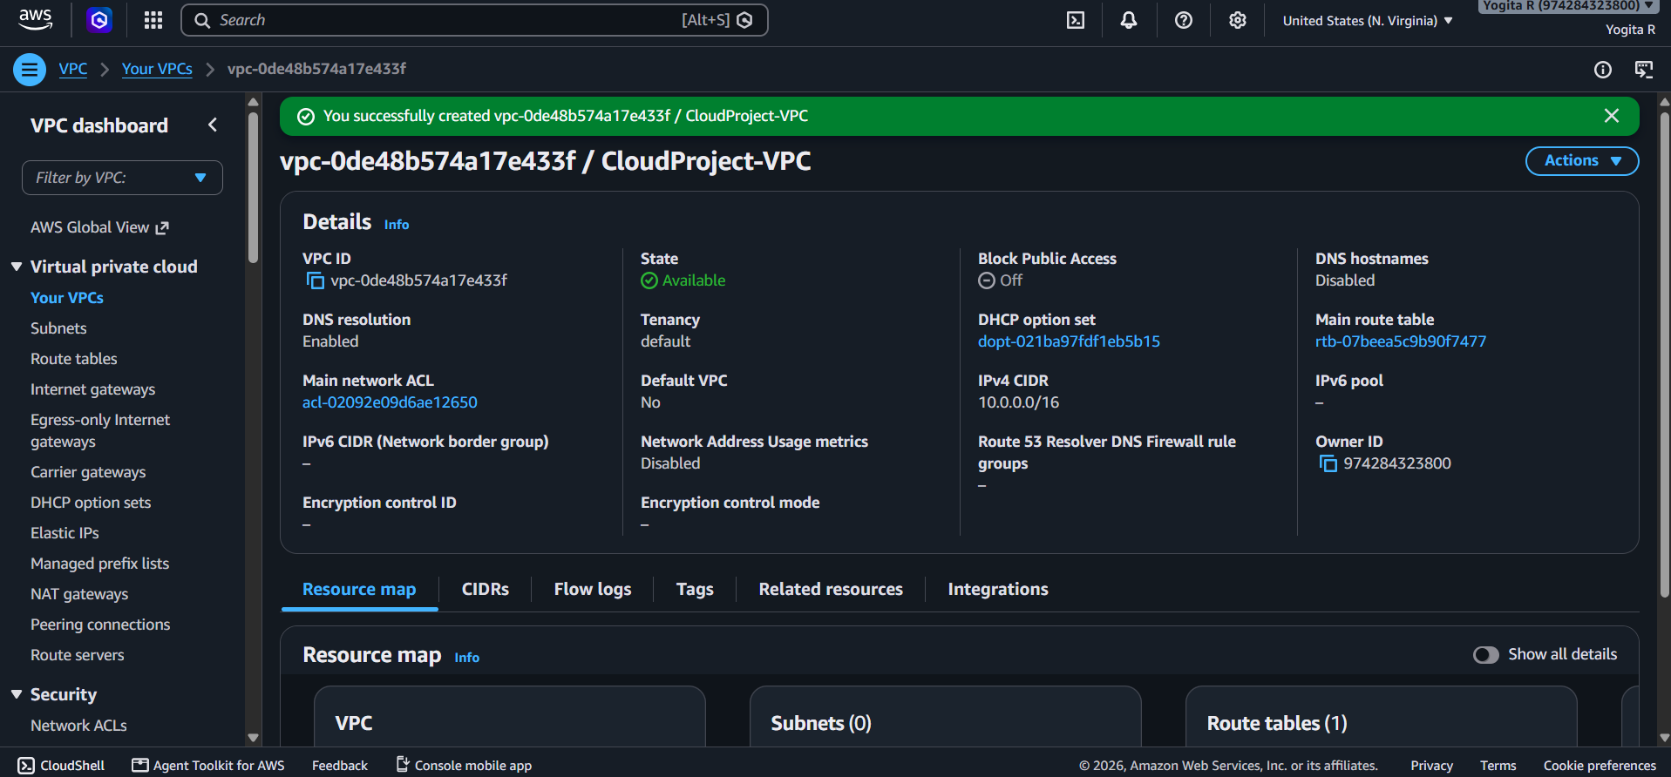

Subnet configured inside the AWS VPC
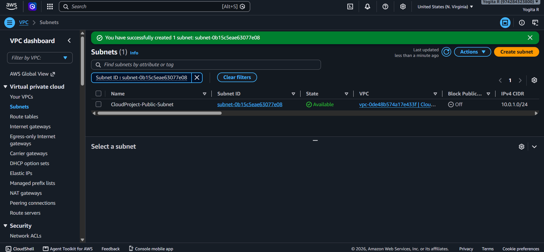
Internet Gateway attached to the VPC
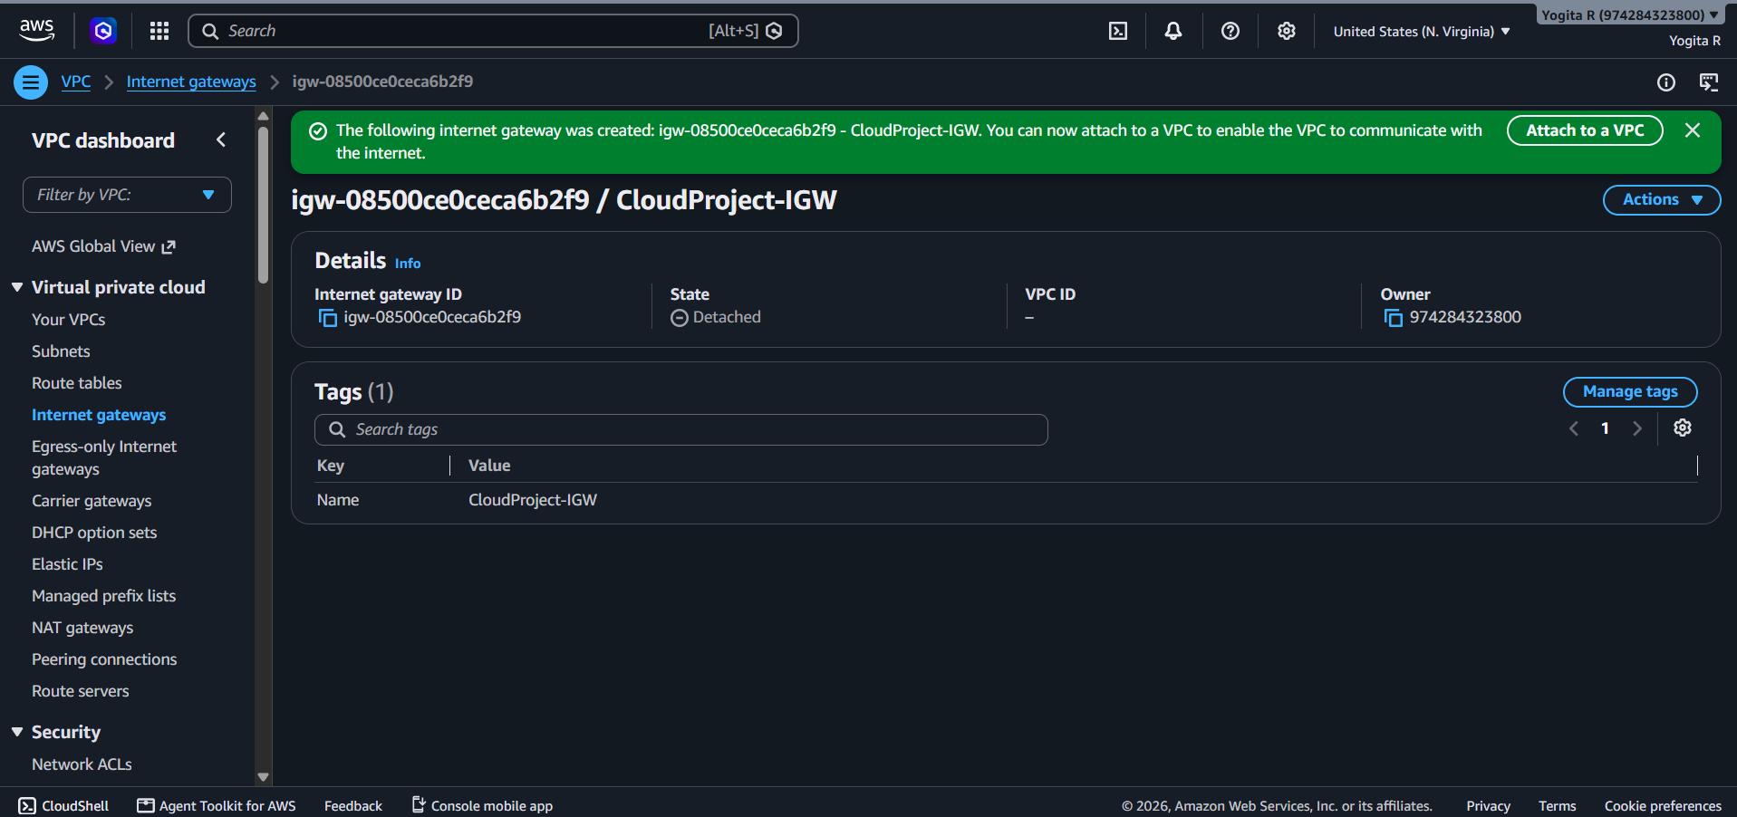
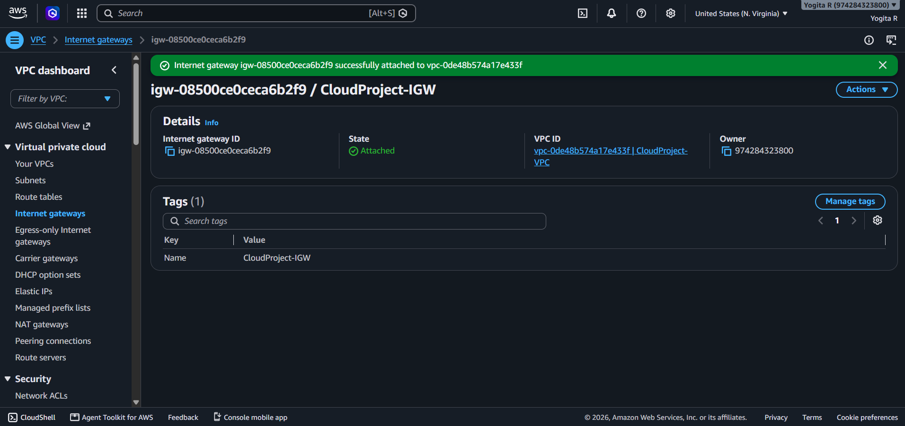
Route table configured for internet connectivity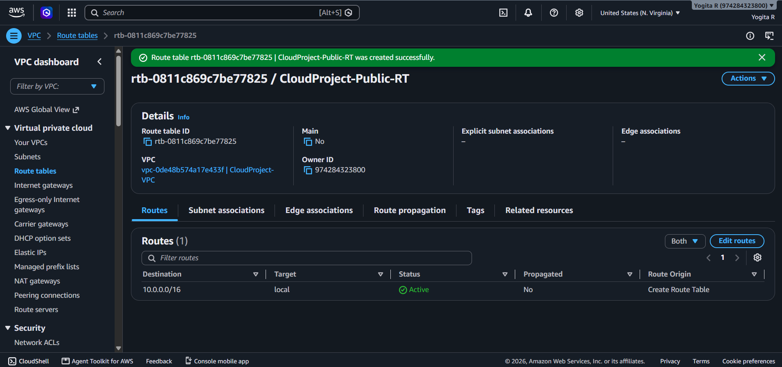
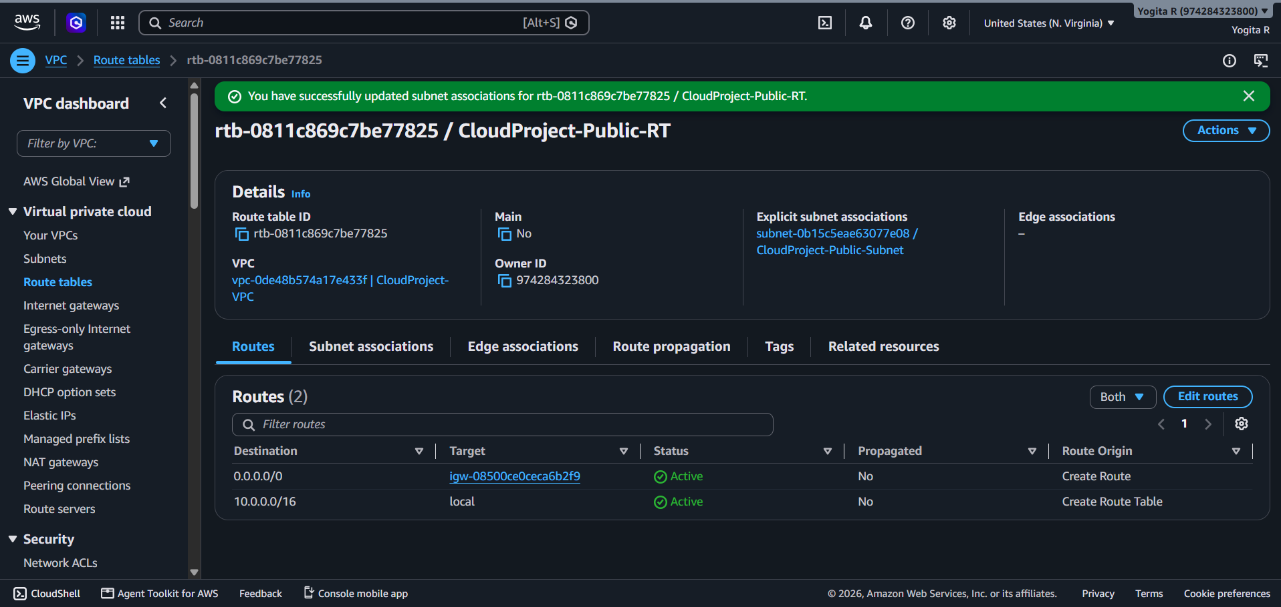
Security Group inbound rules configured for the application
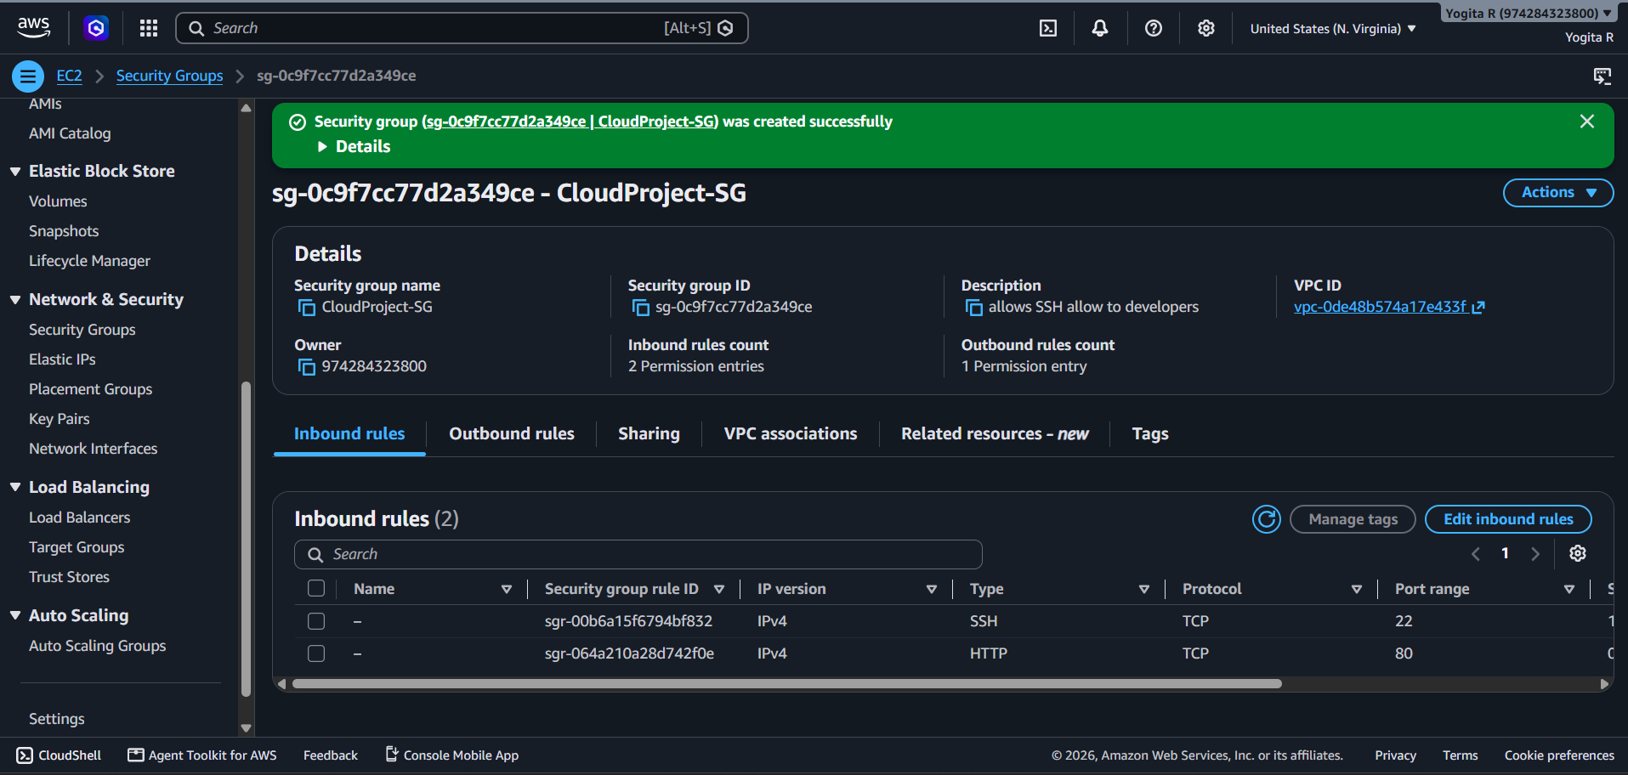

EC2 Instance
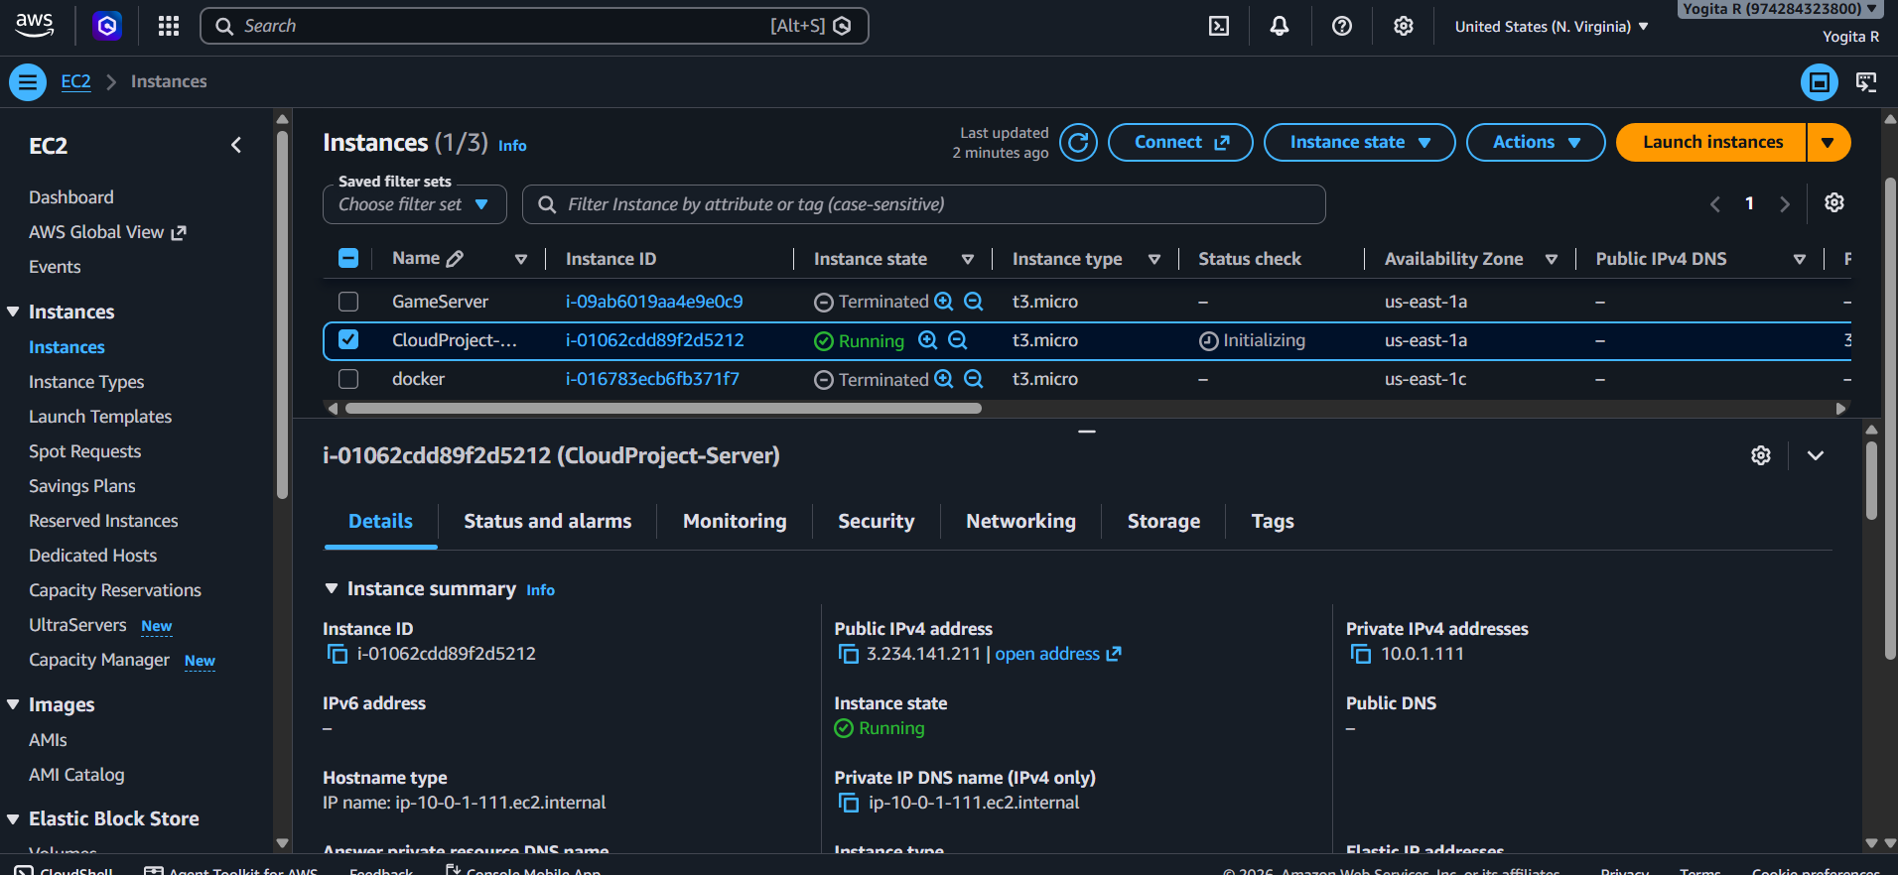
ROUND 3 — DATA INTEGRATION AND DEPLOYMENT
1. Create RDS Database
Created an Amazon RDS database for storing application data.
2. Configure RDS
Configured the database settings and required security access.
3. Create S3 Storage
Created and configured an Amazon S3 bucket for storing application files.
4. Upload Data to S3
Uploaded the required application files and data into the S3 bucket.
5. Integrate RDS and S3
Connected the application with Amazon RDS and Amazon S3 for database and cloud storage.
6. Verify Integration
Tested the application and verified that data and files were stored successfully.
Configure the RDS Database
1. Open the RDS database created in Round 2.
2. Connect to the database from the EC2 instance.
3. Create the required database/table structure.
4. Insert sample application data.
5. Verify that the data can be retrieved successfully.
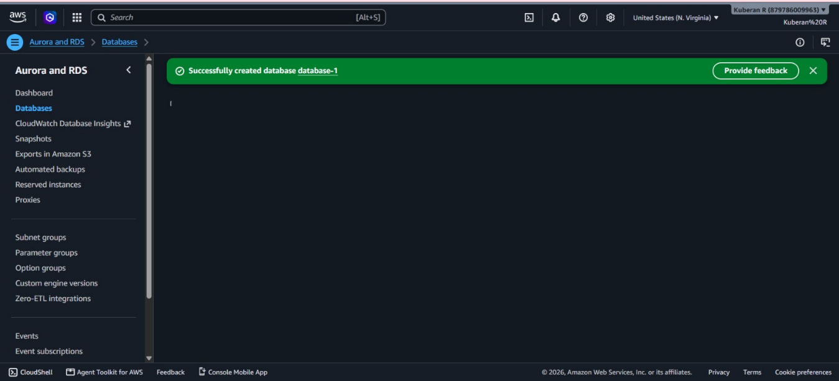

Upload Application Data to S3
1. Open the S3 bucket created in Round 2.
2. Create a suitable folder/prefix for application data if required.
3. Upload the required dataset/files.
4. Verify that the objects are encrypted and versioned.

